VPC Task - 01  
  
  
1) Create VPC with 2 private and 2 public sub-nets.  
  
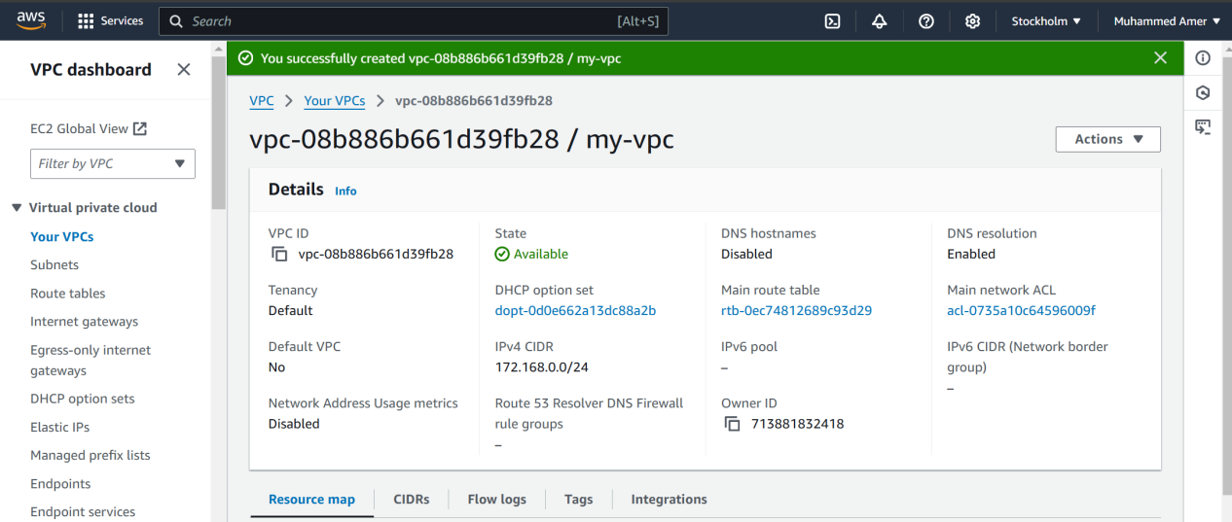  
  
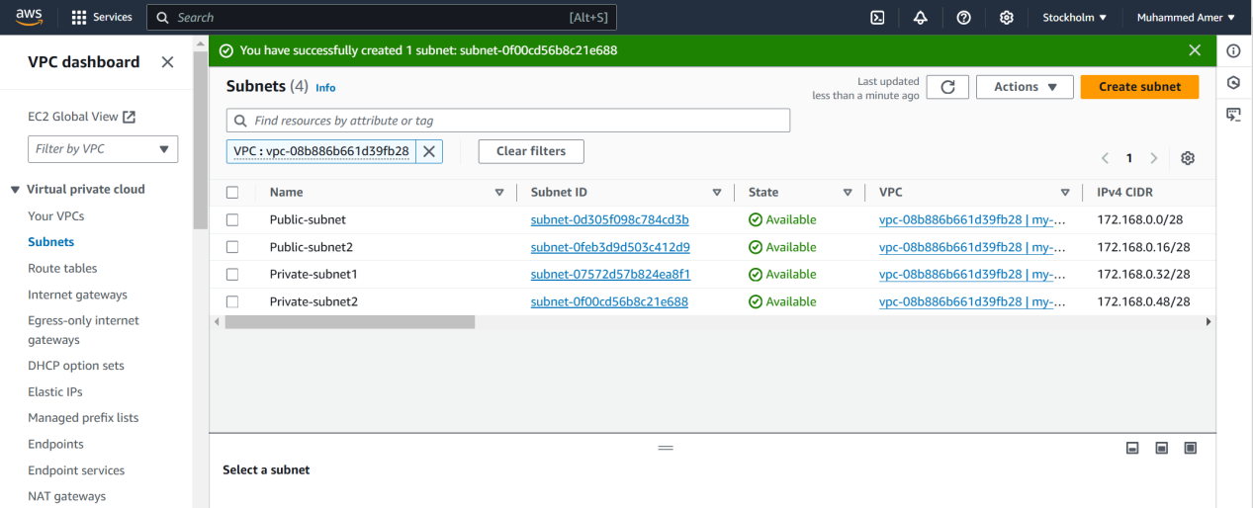  
  
  
2) Enable DNS Host-name in VPC   
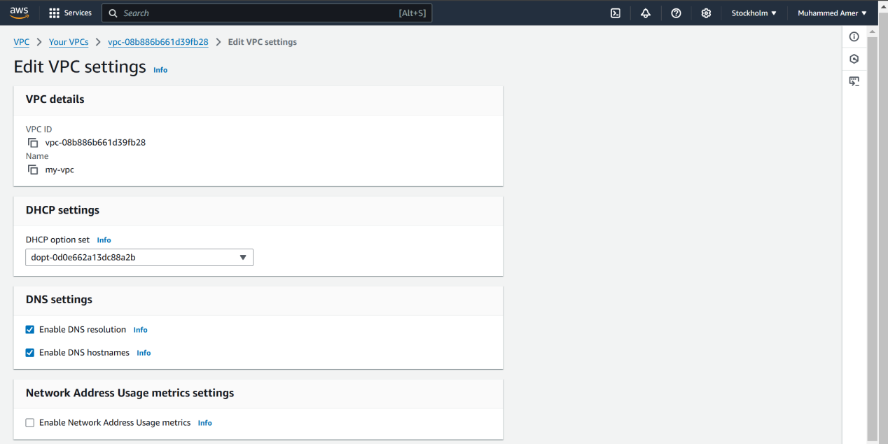  
  
  
  
3) Enable Auto Assign Public IP in 2 public sub-nets   
  
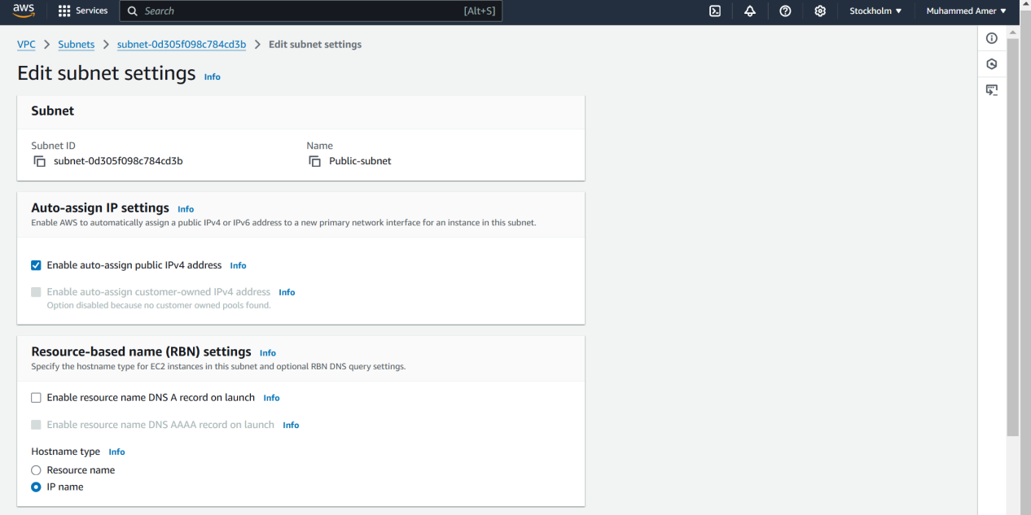  
  
  
  
  
  
  
  
  
  
4) Add 2 private sub-nets in private route table   
  
  
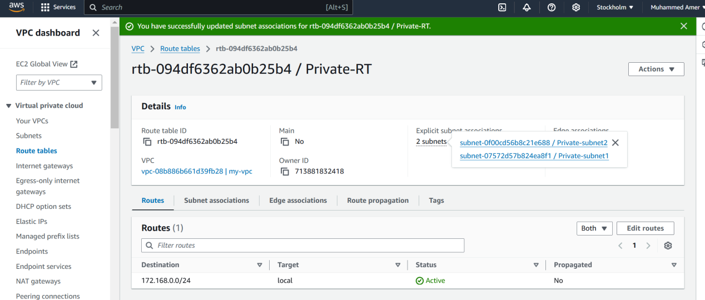

5) Add 2 public sub-nets in public route table   
  
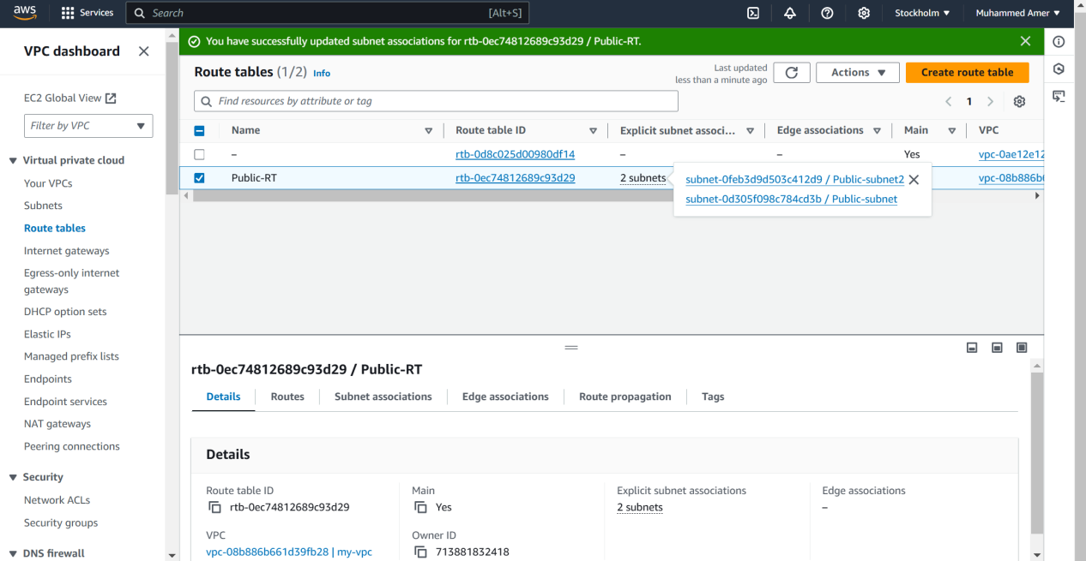  
  
  
  
  
  
  
  
  
  
  
6) Public route table will have the routes to internet and local   
  
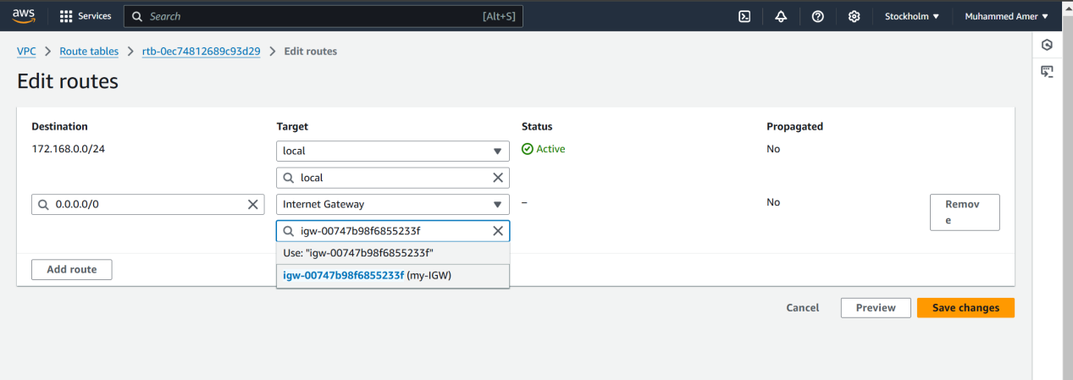  
  
  
  
  
  
  
  
7) Create Ec2 in public sub net with t2micro and install PHP

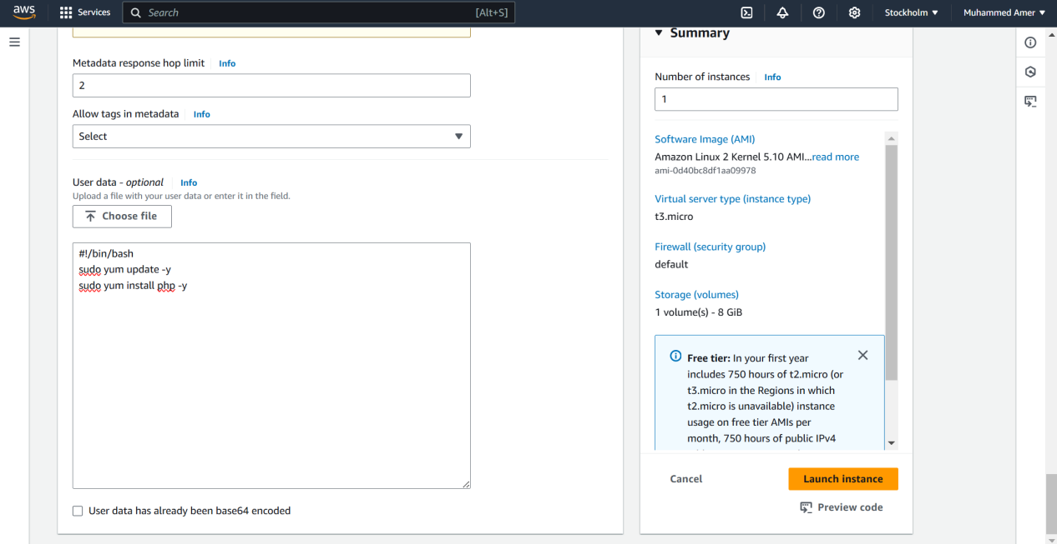  
  
  
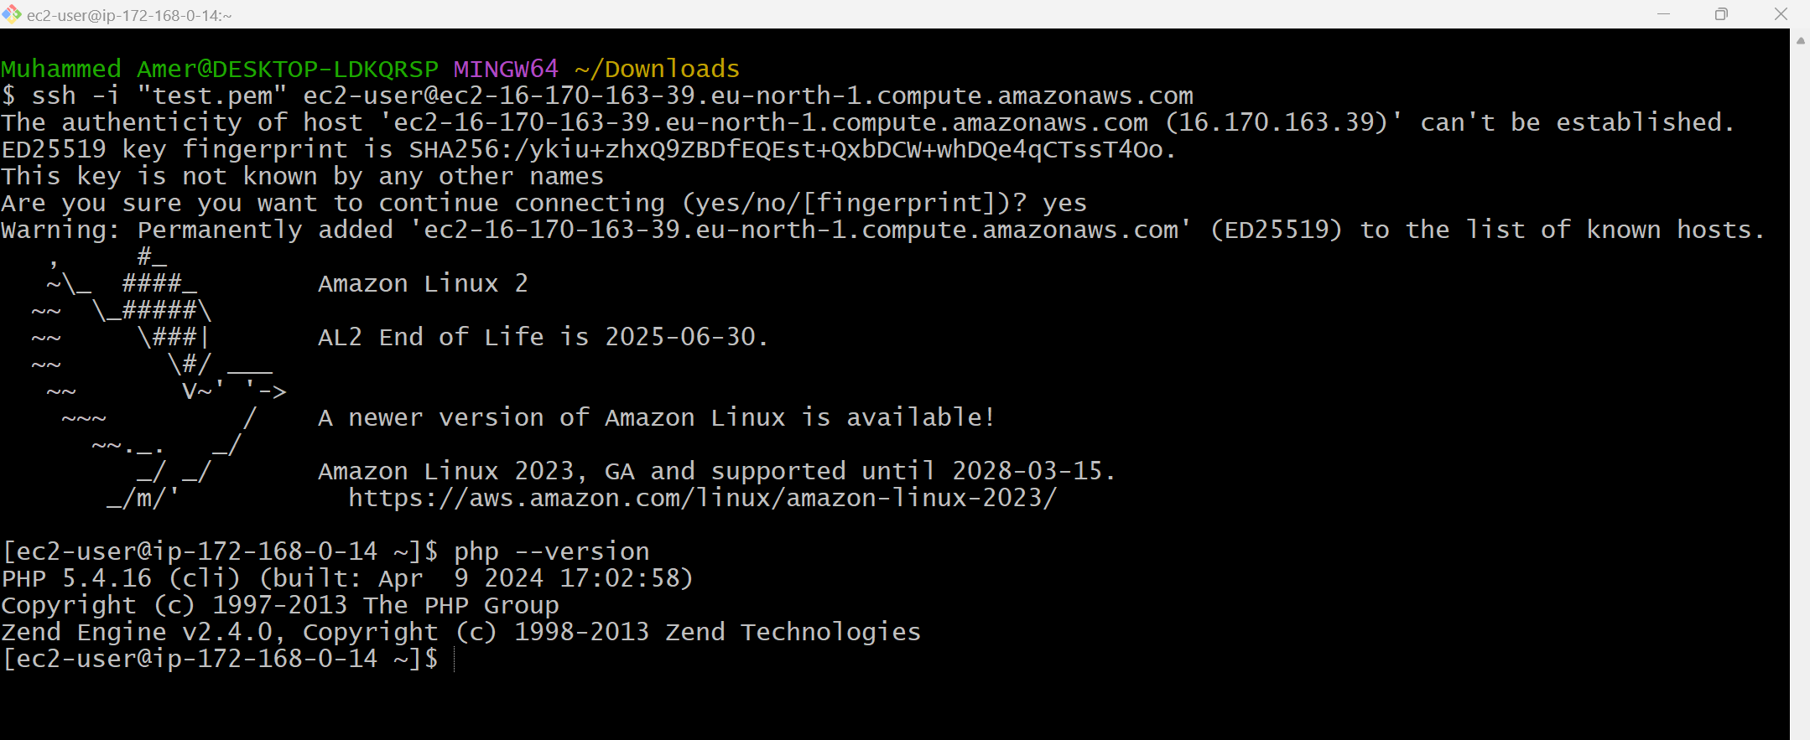  
  
  
  
  
  
  
  
  
  
  
  
  
  
  
  
  
  
8) Configure Nat gateway in public sub net and connect to private Instance   
  
Jump server  
  
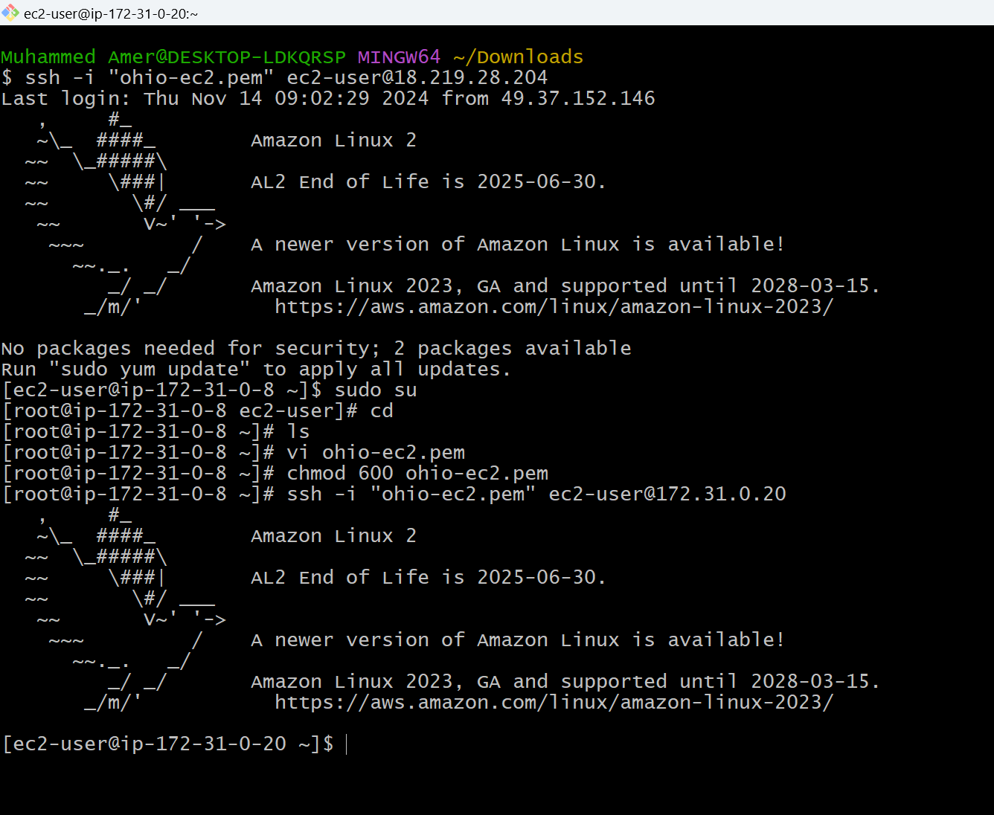  
  
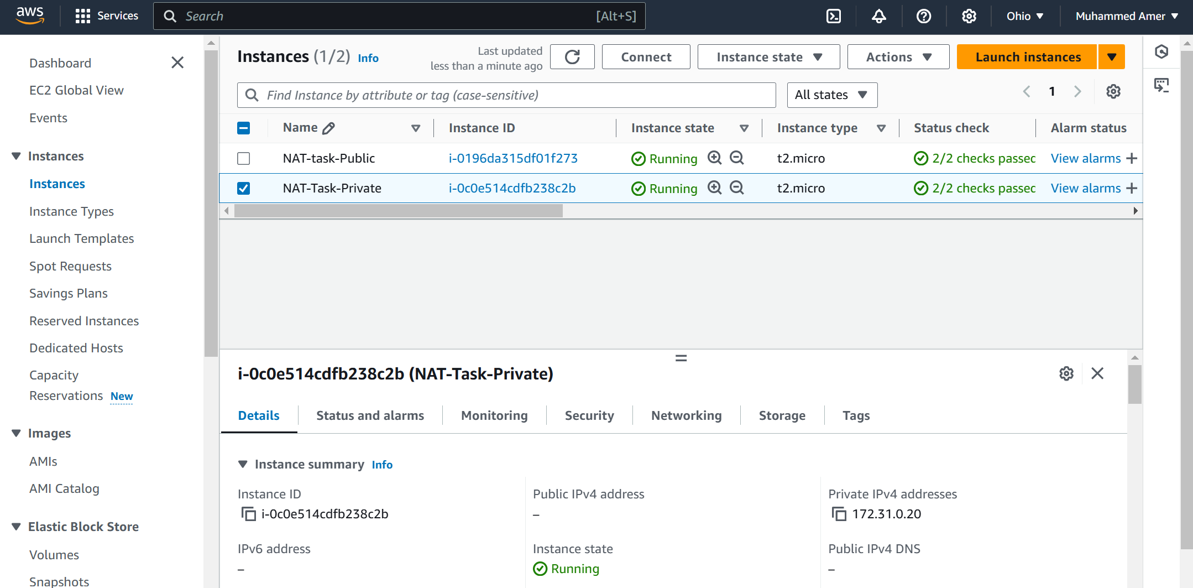  
  
  
  
  
  
  
  
  
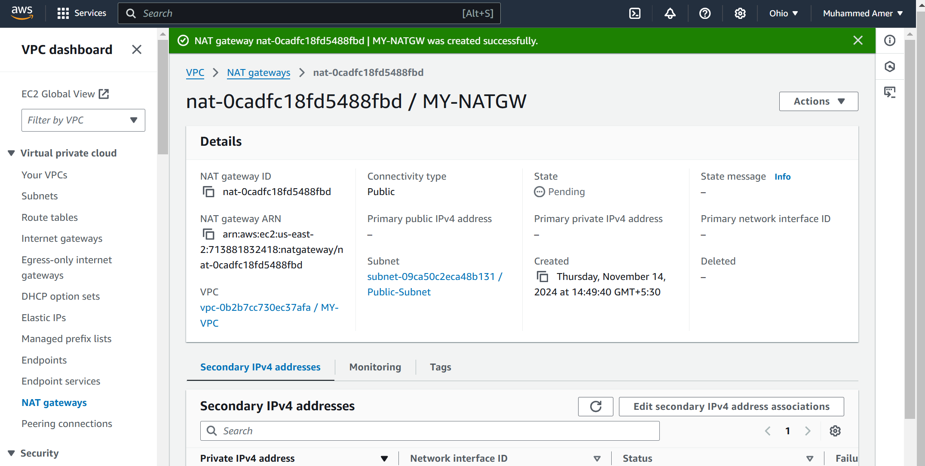  
  
  
  
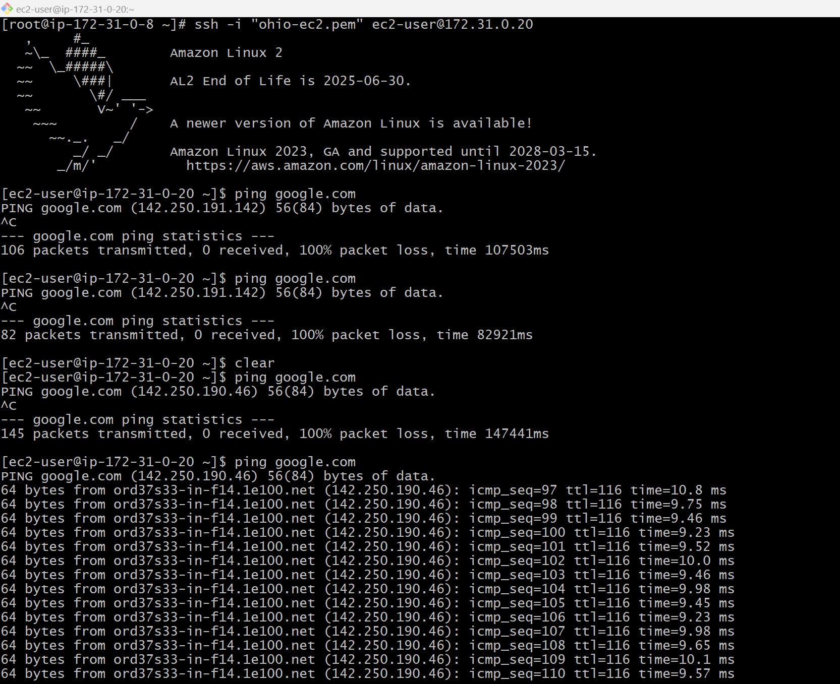  
  
  
  
9) Install Apache Tomcat in private ec2 and deploy a sample app.  
  
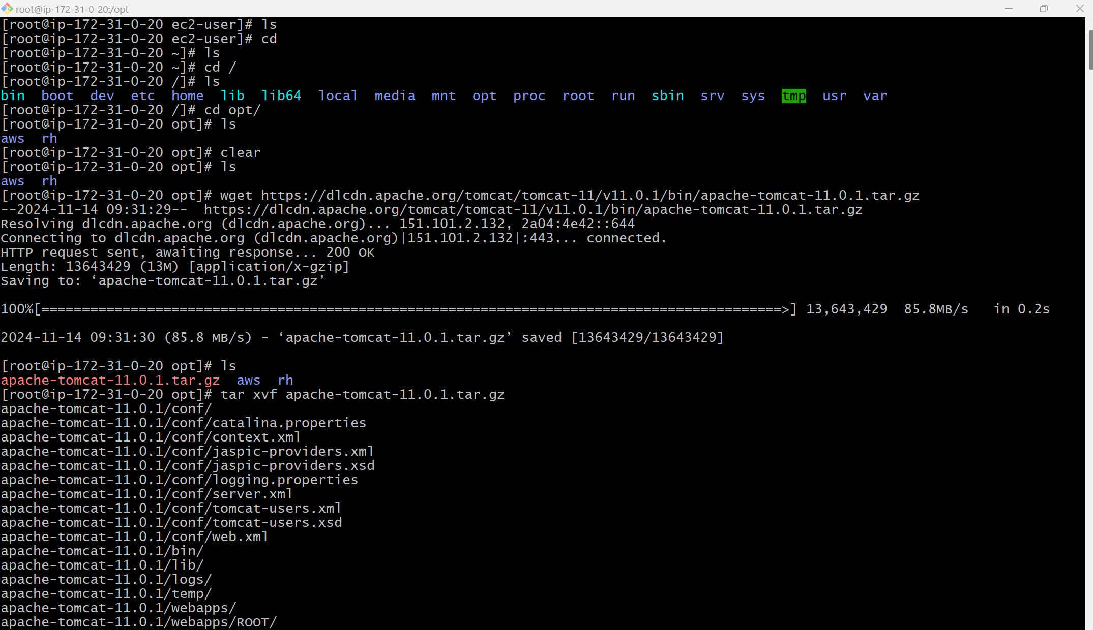  
  
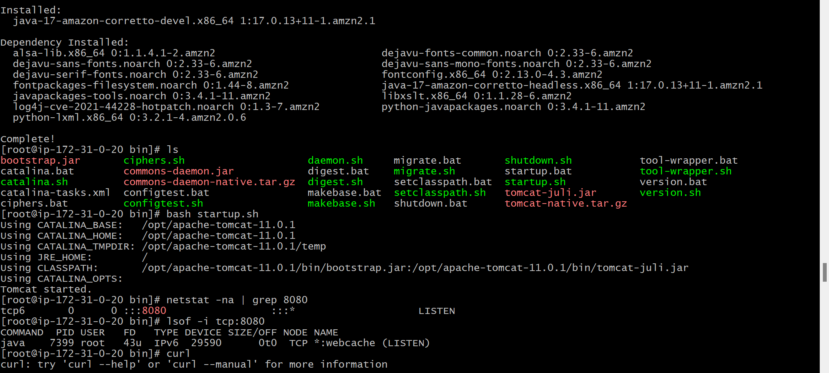  
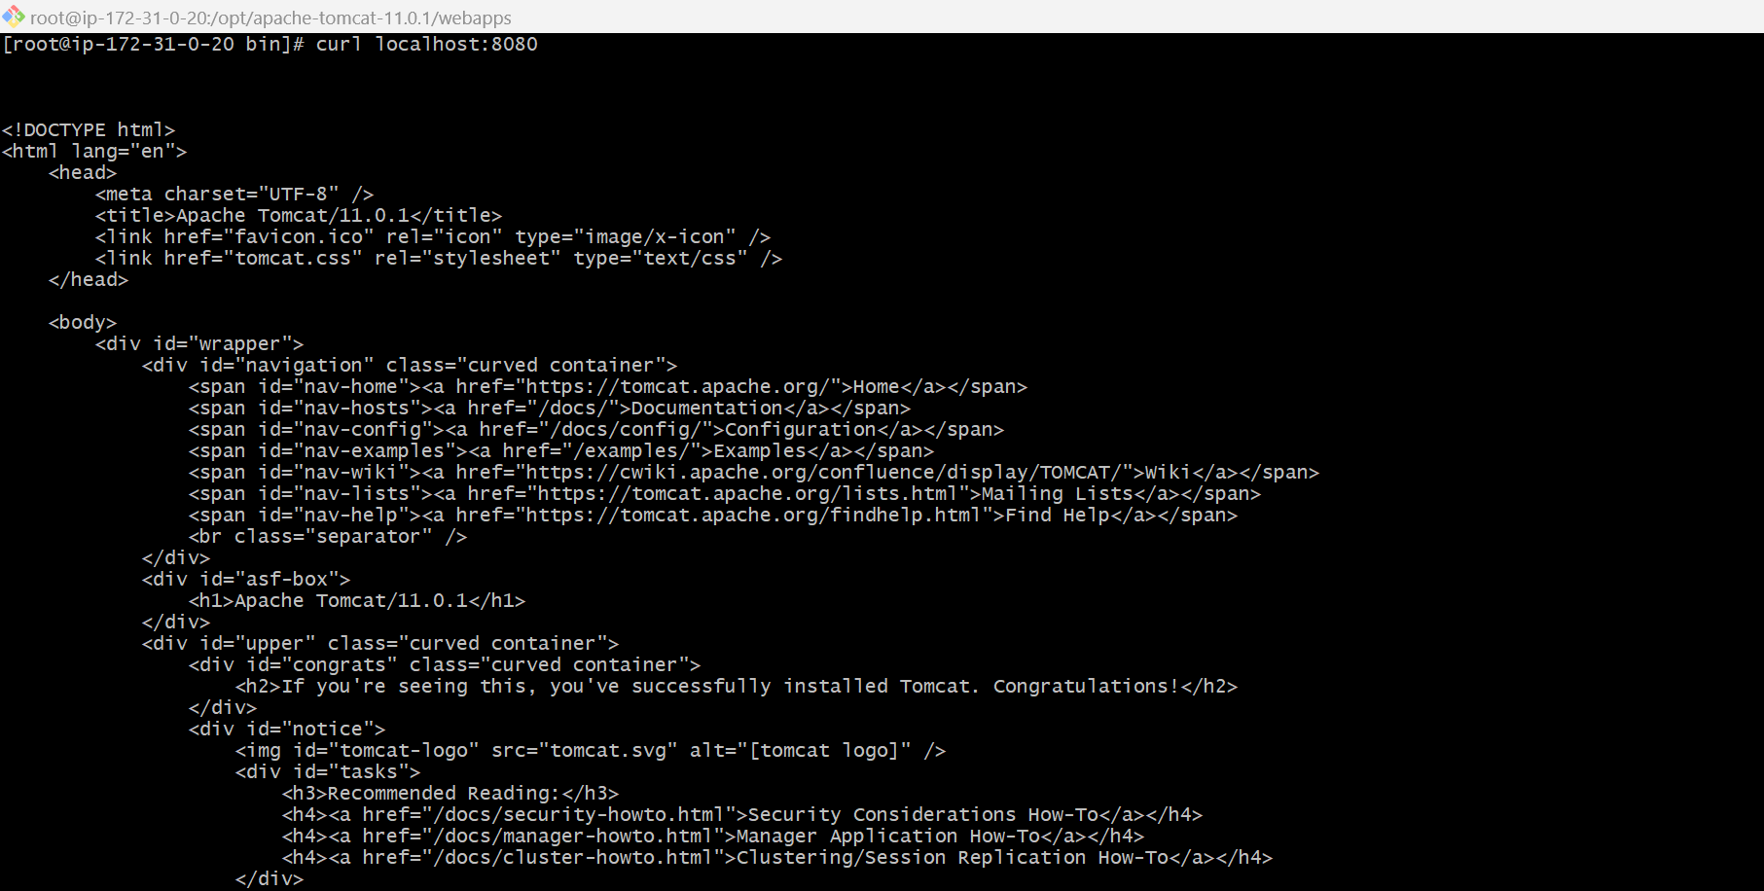  
  
  
  
  
10) Configure VPC flow logs and store the logs in s3 and cloud-watch.  
  
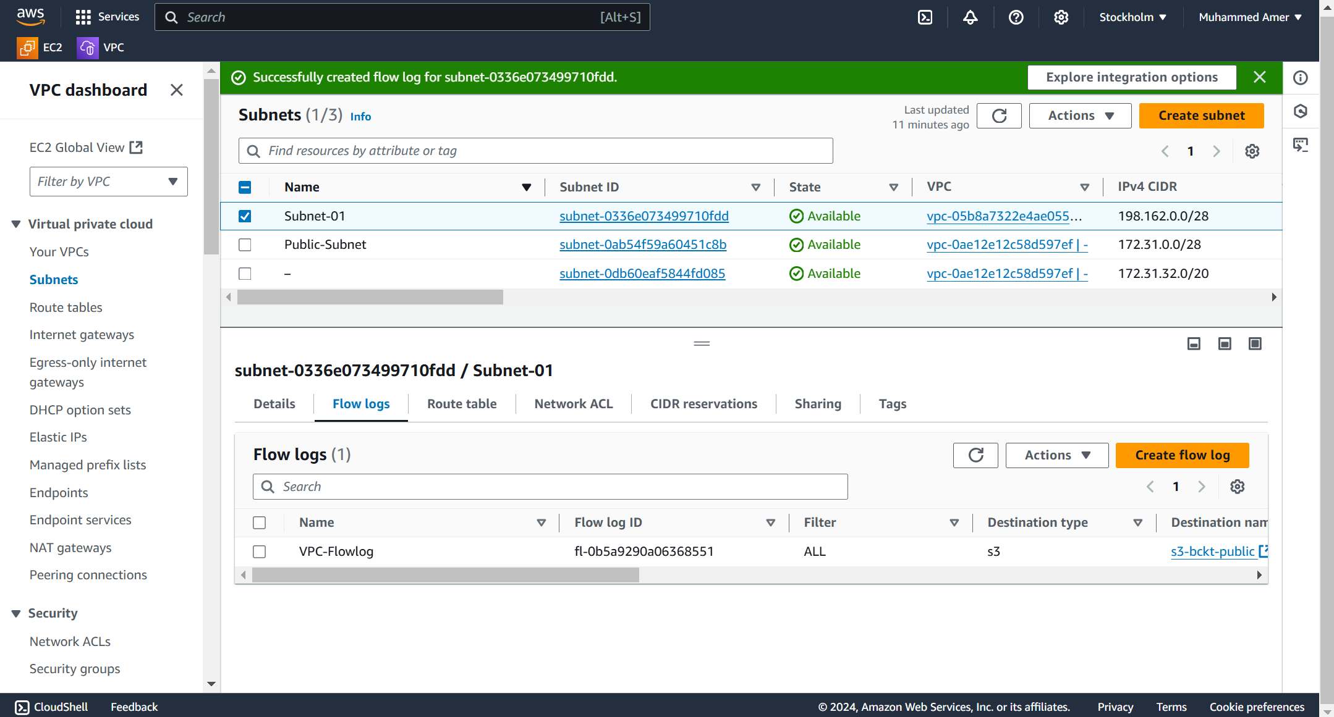  
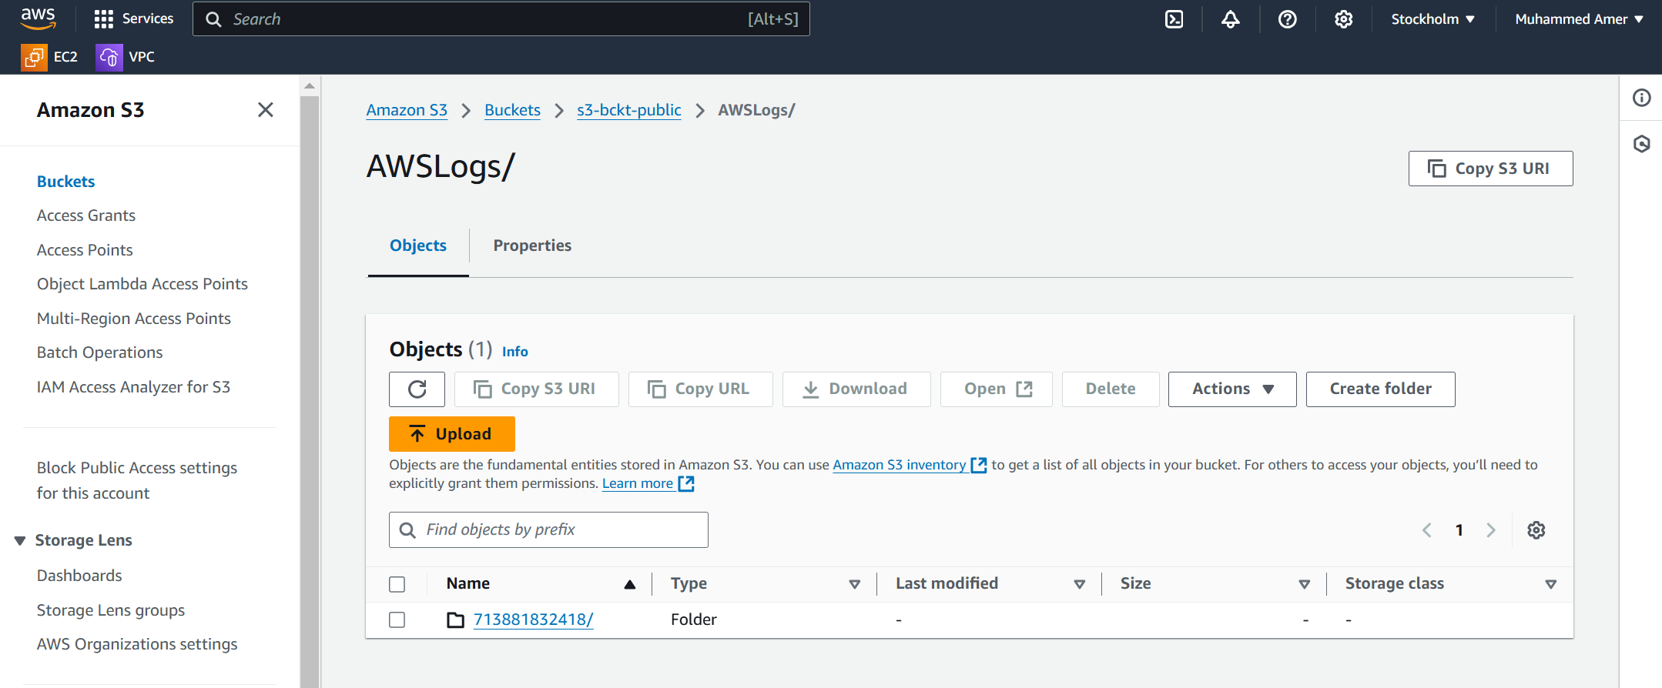  
  
Cloud watch  
  
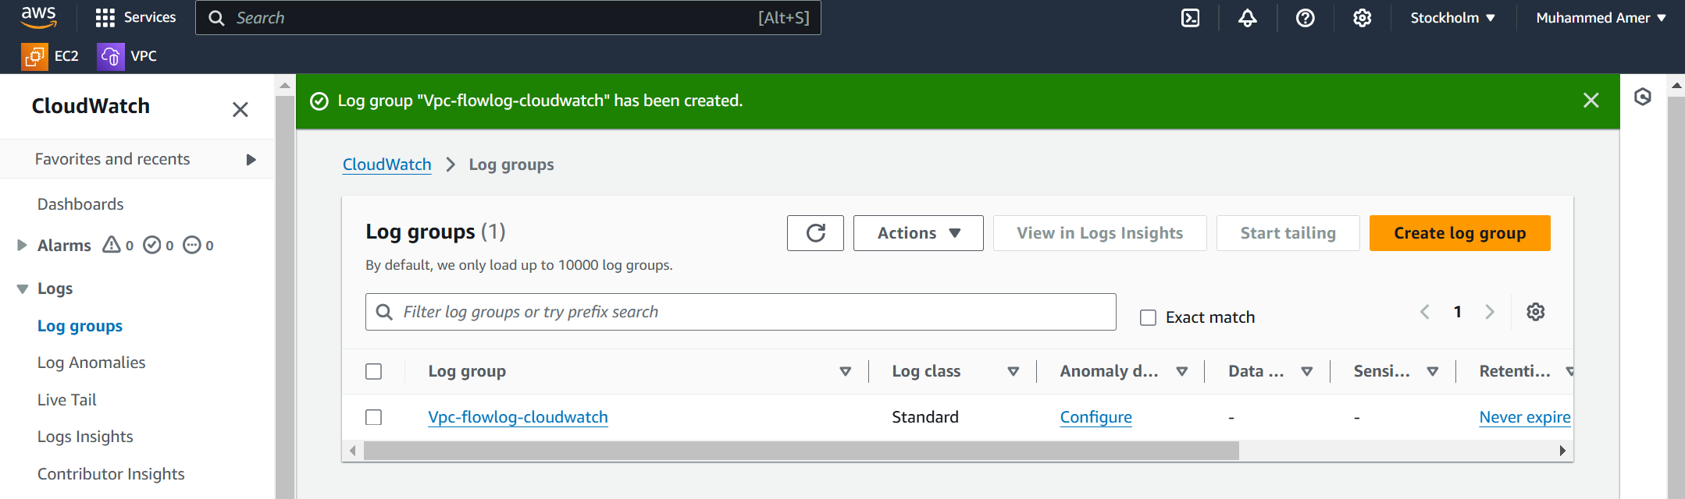  
  
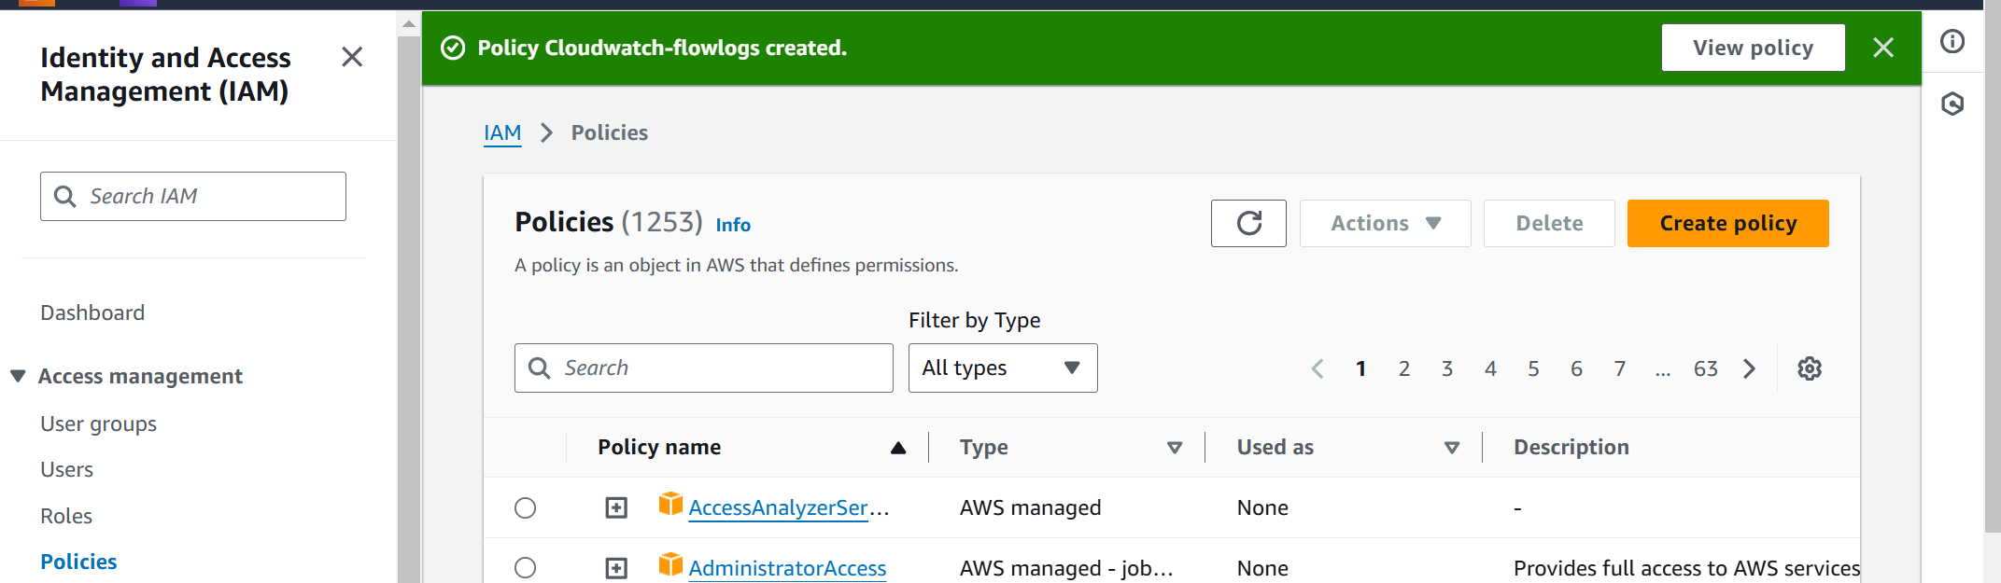  
  
  
  
  
  
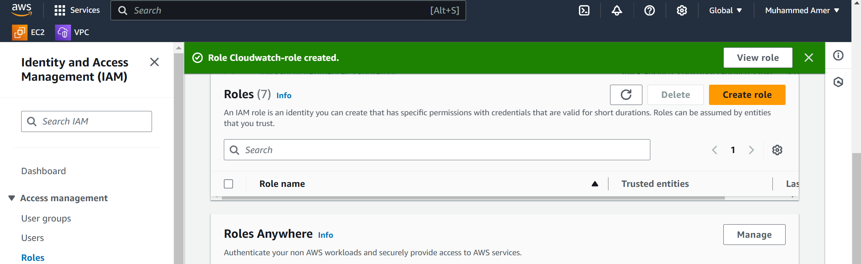  
  
  
  
  
  
  
  
  
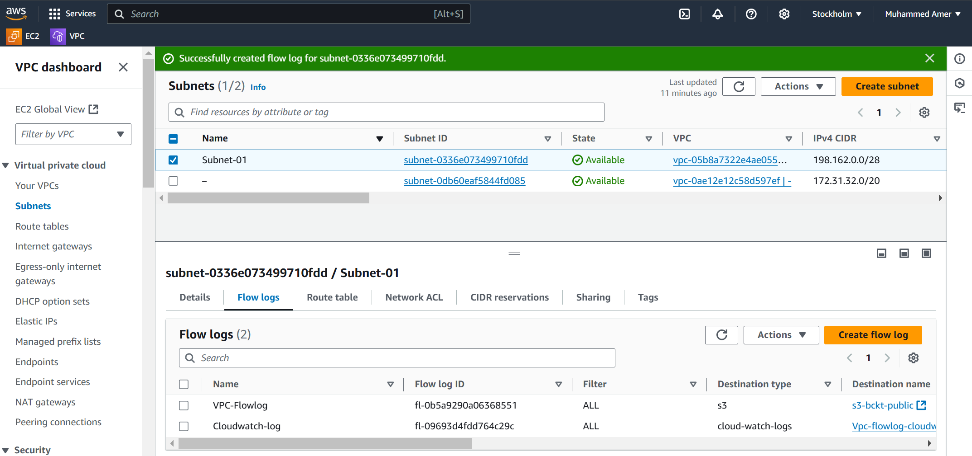  
  
  
  
  
  
  
  
  
S3-logs  
  
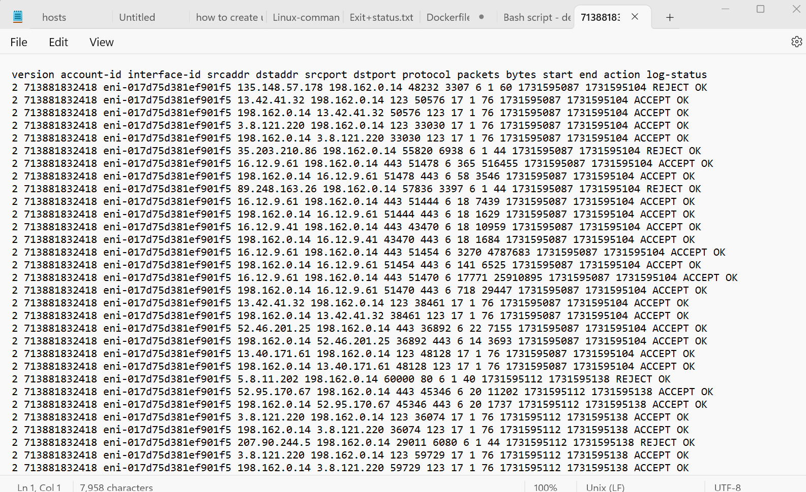  
  
  
  
  
  
  
  
  
  
  
Cloud-watch-logs  
  
